(A) S.NO. : 01-MM_MASTER-07

(B) TRANSACTION CODE : XK01

(C) ACCESS PATH : : LOGISTICS → MATERIALS MANAGEMENT →
PURCHASING → MASTER DATA → VENDOR →
CENTRAL → CREATE (XK01)

FINALLY CLICK THIS “TICK BUTTON”.

ENTER (a) COM. CODE,(b) PUR. ORG. (c) ACCOUNT GR.

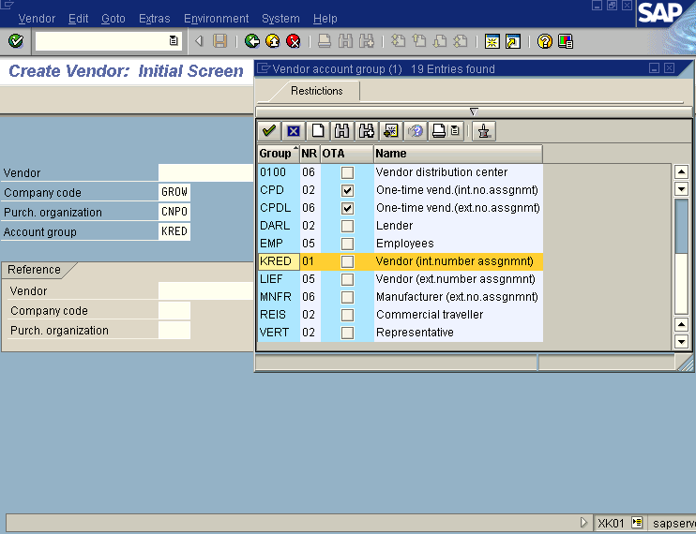

FILL THE FIELDS AS PER REQUIREMENTS.

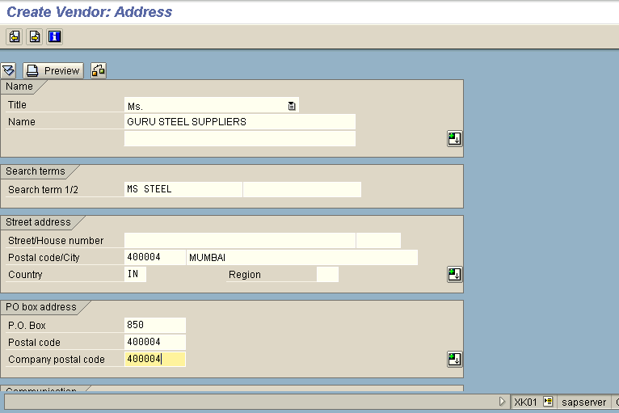
MANDATORY FIELD


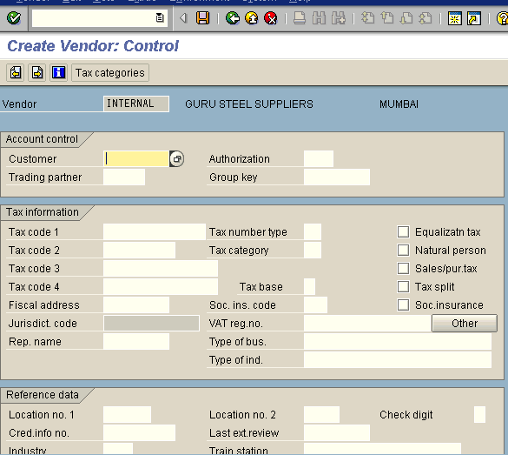
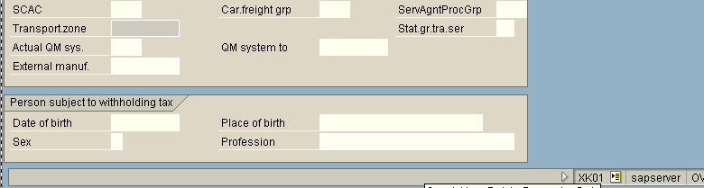

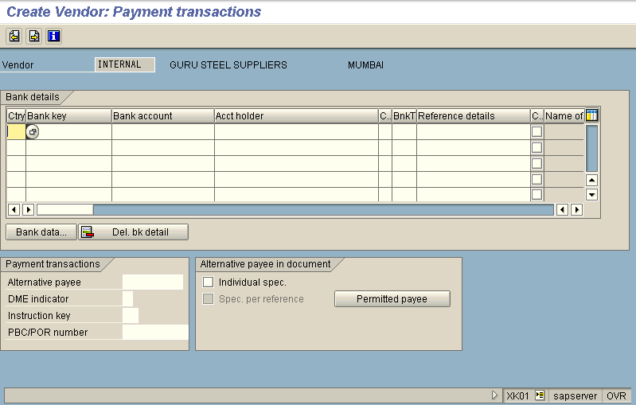

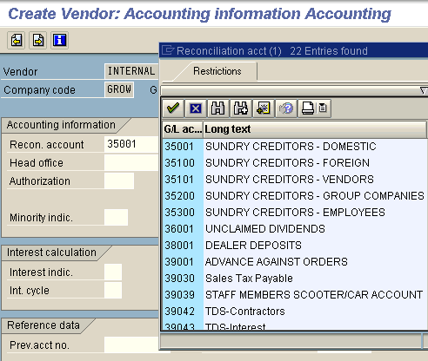
RECON. ACCOUNT: 35100 IS APPLICABLE TO

SUNDRY CREDITORS-FOREIGN

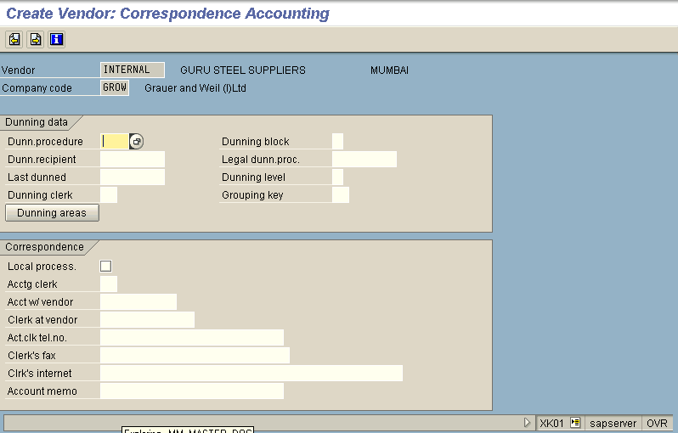

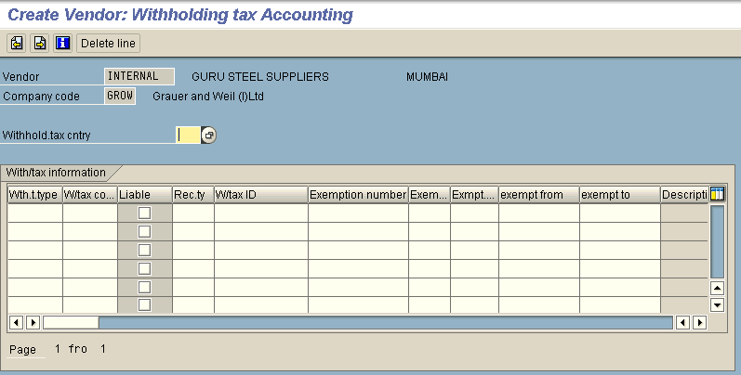

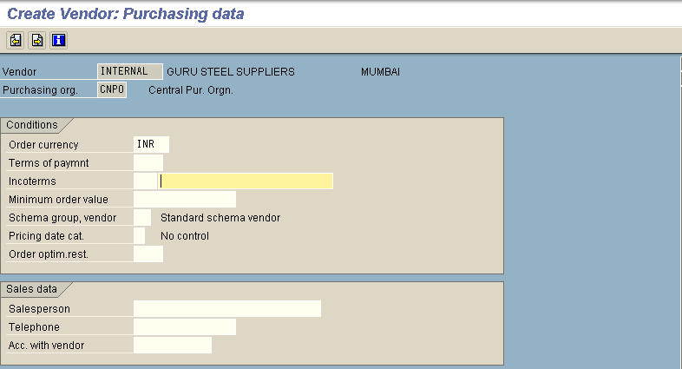

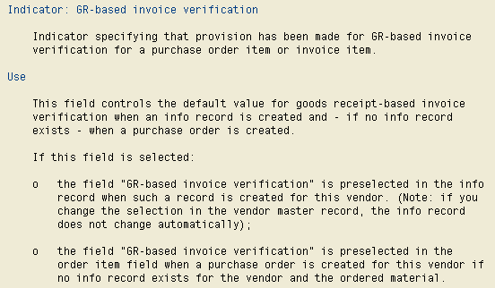

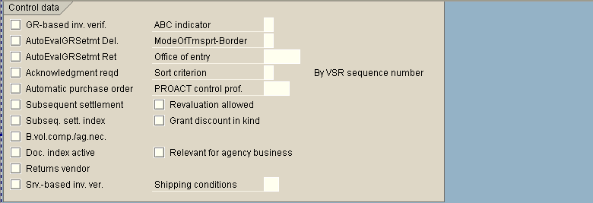

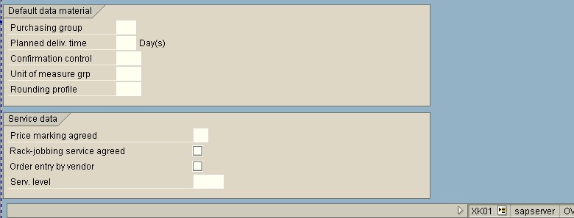

RECON. ACCOUNT: 35100 IS APPLICABLE TO

SUNDRY CREDITORS-FOREIGN

RECON. ACCOUNT: 35100 IS APPLICABLE TO

SUNDRY CREDITORS-FOREIGN

